Claim Registration screens documentation

First Delivery

1) Accident screen

2) OD PD BI Screen – when OD Selected

3) OD PD BI Screen – When PD / BI Selected

4) Service provider screen – when insurer selected

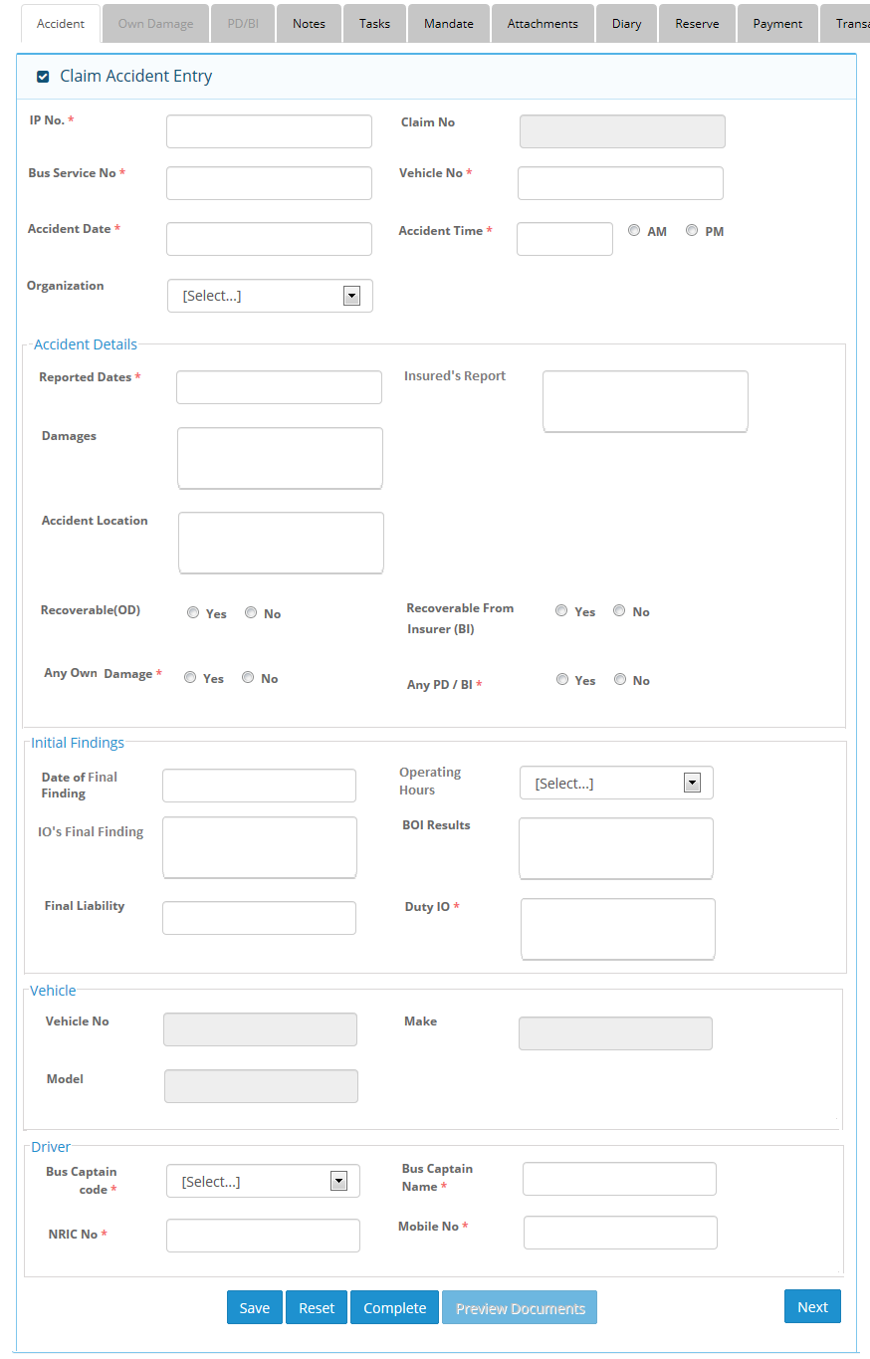

1) Accident Screen
Change to Any Property Damage / Bodily Injury Claim
2) OD PD BI Screen when OD selected
1) Combine OD, PD/BI Tab into Claims
2) Change Third Party Entry to Claim Entry
3) Column Headers change to Claim No. | Claim Type | Claimant Name | Action
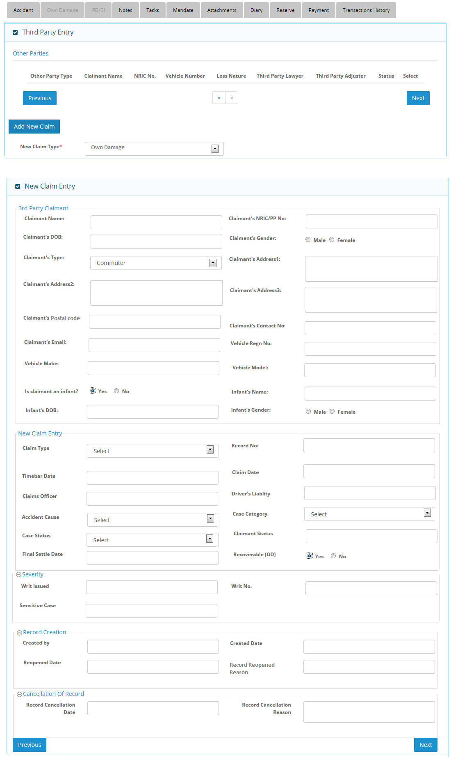

3) OD PD BI Screen when PD selected
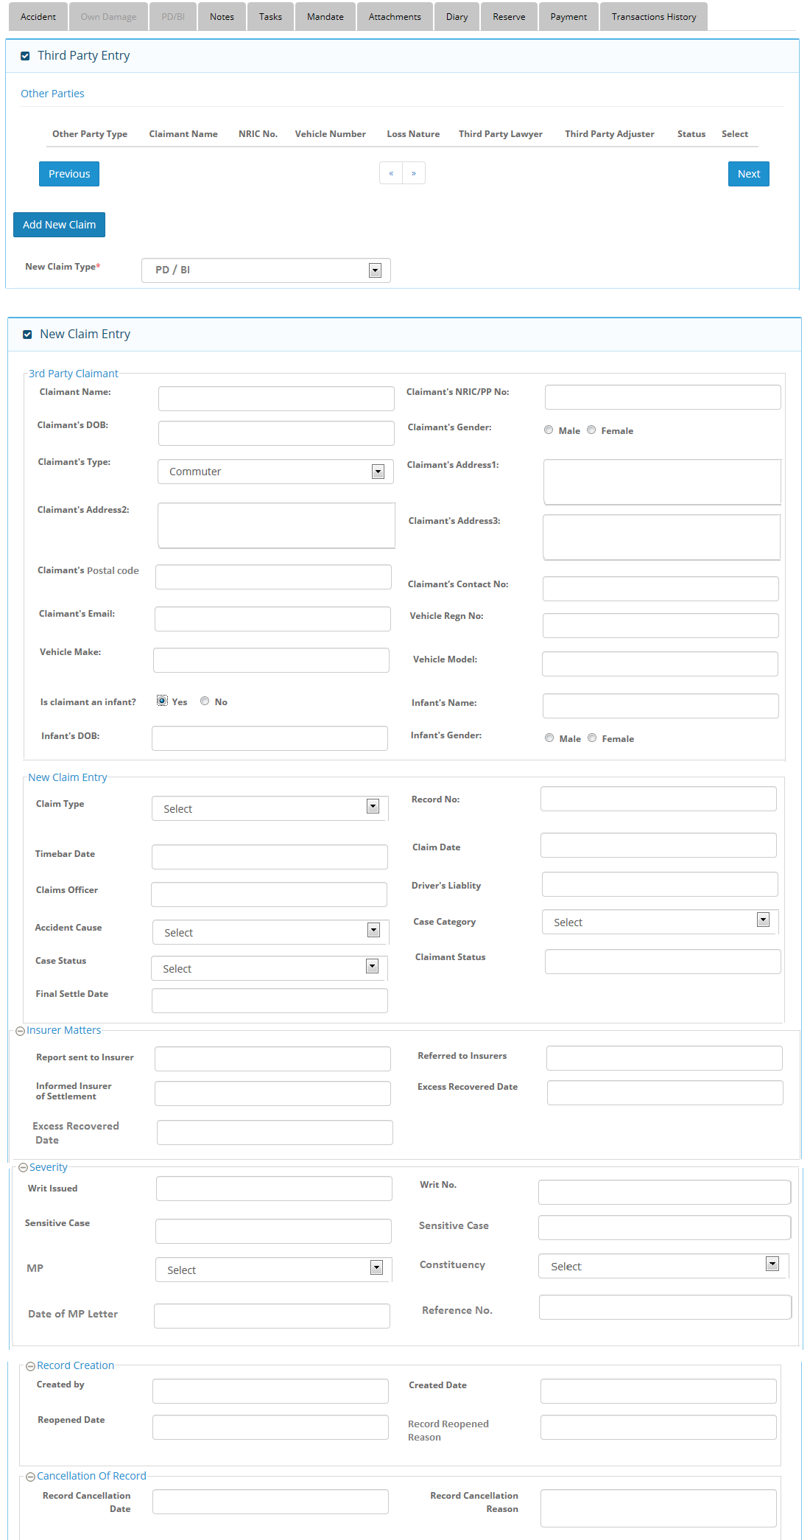

Selection:
- Property Damage (TPPD)
- Bodily Injury (TPBI)
4) Service provider screen – when insurer selected
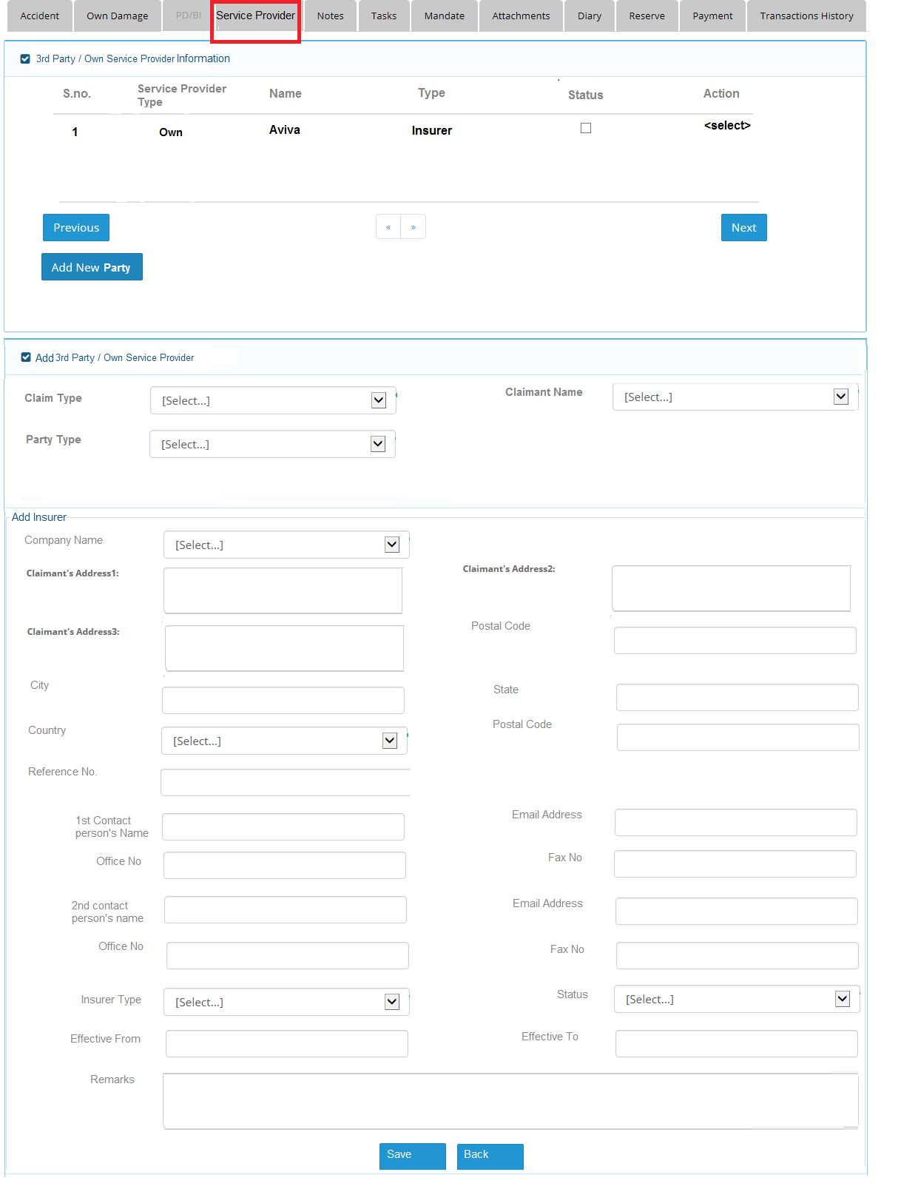
Insurer Type, Effective From and Effective To to be removed.

